Clean, Fun and Engaging reads for the teen girl
The criteria for picking this list of books was genre, clean reading and appeal to teen girls. The types of book are sci-fi, realistic, and historical fiction books that I would recommend to a parent who would like their young teen daughter to read a book that is engaging without fear of inappropriate material.

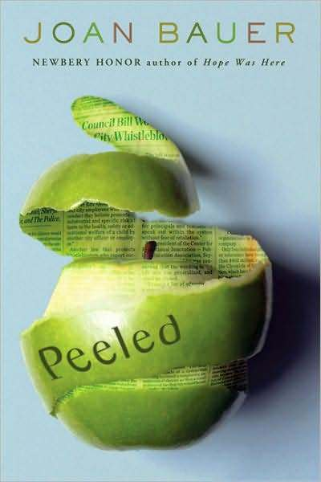
Bauer, Joan. Peeled. New York: Putnam, 2008.
This book is set in a small farming community of Banesville, NY. Strange stories have been circulating about the old Ludlow house. People say the ghost of the last owner, who was mean-spirited in life and even more so in death, is haunting the place, causing harm and even death to people who dare to visit the “haunted” house. It doesn’t help matters any that the local newspaper is helping to spread the rumors. This book was included in the list because of the age appropriateness and suspense that would keep the reader engaged throughout the story.

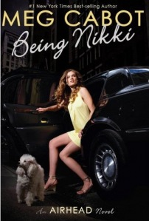
Cabot, Meg. Being Nikki: An Airhead Novel. 1st ed. New York: Point, 2009
As a first in a series, this story contains everything that would keep a teen girl interested. This novel is part romance, part crime thriller, and part comedy with a little celebrity culture. All of this blended into an entertaining mix makes for a great teen read. Em is a16-year-old that has her brain transplanted into supermodel Nikki's body. The story turns in some surprising directions, but Em's first-person narrative is as engaging to the reader. The final plot twist will have readers excited to dive into the sequel.

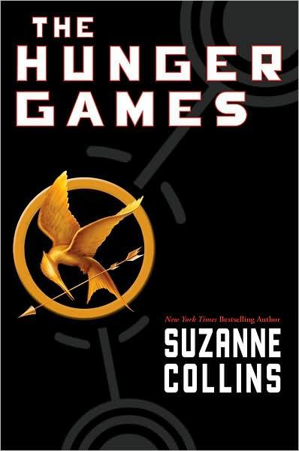
Collins, Suzanne. The Hunger Games. 1st ed. New York : Scholastic Press, 2008.
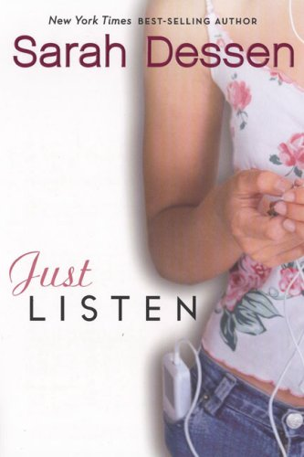
In this sci-fi young adult adventure, the characters seem realistic as they form alliances and friendships in the face of overwhelming odds. The plot is tense, dramatic, and engrossing that is weaved around the life of a 16 year old girl. This story was based in the not-too-distant future; the United States of America has collapsed, weakened by natural disasters and war. It becomes a country that is divided into the Capitol and 12 districts. Each year, two young representatives from each district are selected by lottery to participate in The Hunger Games. When 16-year-old Katniss’s young sister is selected as the mining district’s female representative, Katniss volunteers to take her place. The setting of a futuristic plot enhances the appeal of the book.
Dessen, Sarah. Just Listen. New York: Speak, 2008.
I love Sarah Dessen’s stories. They are realistic fiction stories that teen girl can relate to without all of the blushing details. This story unfolds when sixteen-year-old Annabel feels isolated from friends who believe the worst of her because she has not been truthful with them. She becomes friends with a classmate Owen, whose honesty and passion for music help her to face and share what really happened at the end-of-the-year party that changed her life. Annabel's family's refuses to acknowledge that it has problems. Annabel listens to her own heart and risks speaking out honestly.
Dessen, Sarah. Lock and Key. New York: Speak, 2009.
The characters in this Sarah Dessen book had real problems similar to teens today. This story makes it easy to connect with the life of Ruby. Ruby is abandoned by her mother and determined to make it on her own, especially when she is sent to live with her long-lost sister in a whole new world of privilege, family, and relationships. As Ruby learns, there's a big difference between being given help and being able to accept it. And sometimes, it takes reaching out to someone else to save yourself. This is a great story that teaches humility and acceptance.
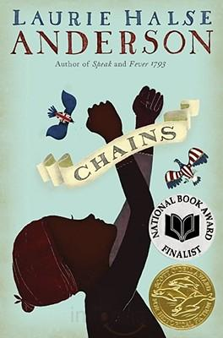
Halse-Anderson, Laurie. Chains: Seeds of America. Waterville, Maine: Thorndike Press, 2009

This intriguing story about a slave girl is a national book award finalist. Laurie Halse Anderson has some great teen writing and this one is no exception. The story line is a historical fiction story from the start of the Revolutionary War. Isabel, a slave, is sold to a cruel loyalist family even though she has been promised freedom by her former owner. She is faced with the choice of working for or against the British. Isabel makes the choice to work with anyone who can help her. This is an entertaining and enlightening look into the life of a teen age slave girl.
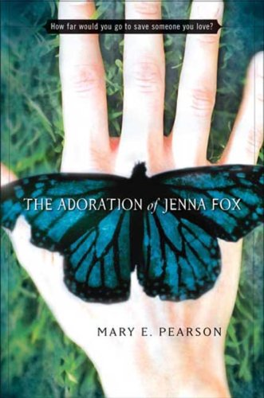
Pearson, Mary E. Adoration of Jenna Fox. 1st ed. New York: Henry Holt, 2008.
This story is about a teenage girl named Jenna Fox. It is an exciting book that teens will not want to put down because of the realistic situations and unrealistic medical discoveries. The Adoration of Jenna Fox begins with a teenager who wakes up from a coma to discover she has no memory of her life or her "accident." Jenna struggles to find her identity and reclaim her past. The novel focuses on how one person's struggle with identity can impact a family, friends, and even people she doesn't know. This book has an interesting twist on a sci-fi teen read.

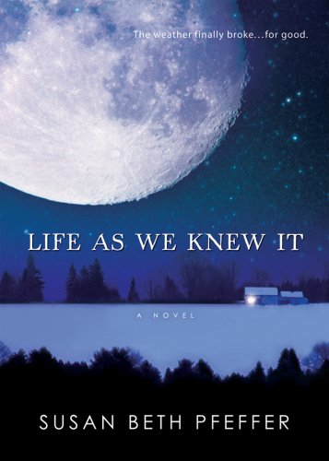
Pfeffer, Susan Beth. Life As We Knew It. 1st ed. Harcourt, 2008
When a meteor strikes the moon, and knocks it closer to Earth, causing fear and confusion on earth. The climate and society are all mixed up and sixteen-year-old Miranda's life in small town Pennsylvania will never be the same. This story is told as diary entries made by Miranda, the average, girl-next-door who is placed in extraordinary circumstances. Miranda is a likeable and identifiable character to teen age girls.

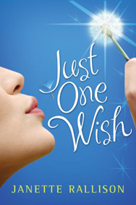
Rallison, Janette. Just One Wish. Putnman Juvenile, 2009
This story deals with a girl who would do anything to help her brother’s wish come true. Teen girls with a sibling will be able to relate to what they might do to help their sick brother or sister. Annika’s little brother has an upcoming surgery. Convinced she knows exactly what her brother will wish for, she offers to grant any wish he makes, hoping that the happiness he feels from his wish coming true will help his surgery go well. He wish is a big one. He wants to meet the actor who plays Robin Hood on TV and invite him to his house so that he can teach him to shootarrows. Annika, being determined to grant her brother’s wish, heads off to the set of Robin Hood to convince the actor to come meet her brother. This is a heartwarming story to make you think about life.

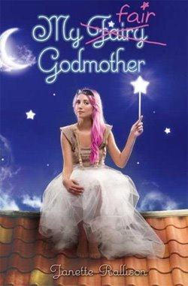
Rallison, Janette. My Fair Godmother. New York: Walter Books for Young Readers, 2009
This story has the twist of a teenage fairy tale and what girl doesn’t love a fairy tale? Sibling rivalry starts when Savannah's boyfriend dumps her for her older sister. She wishes for a true prince. Then Chrissy, her fairy godmother, shows up. She's not really a fairy godmother but a fair fairy student. In her attempts to grant three wishes for Savannah, Savannah is sent to the middle Ages into the stories of Cinderella and Snow White. This is a cute and fun story for any teen age girl to read.

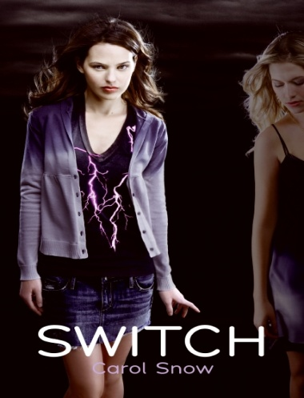
Snow, Carol. Switch. HarperTeen, 2008
This is an out of the ordinary story about a teen age girl named Claire who is a body-switcher. Dealing with adolescence is hard enough for any girl to go through without having to deal with this strange ability. Her grandmother Evelyn is hilarious in this story and made the story unpredictable as to what she would do next. The book has a great message for teen girls about liking yourself the way you are.

Resources

Deliciously Clean Reads for Teens. Homespun Light: Teens (2009) http://homespunlight.blogspot.com/search/label/teen

Deschutes Public Library. Clean Teen Reads (2009) http://www.dpls.lib.or.us/Page.asp?NavID=727

Squeaky Cleen Teen Zone @MPPL. (2009) http://www.mppl.org/teens/squeaky_clean.html

Teenreads.com. (2009) http://www.teenreads.com

Yalsa. Books that don't make you blush. http://www.ala.org/ala/mgrps/divs/yalsa/booklistsawards/popularpaperback/06ppya.cfm

