

Join us for fun and games!

You will never be bored with board games!

Game on @ the Library!!

Check out the library website for more information and game station at [www.blogger.com](http://www.blogger.com). Add your gaming info to our blog!

Game station is so fun! The music rocks and you get to meet people that you normally might not get a chance to talk to!

Carrie –

**10th Grade**

Game day will:

**Who?** 9th-12th Grade Students

**What?** You asked for them and you got them! Come check out the games you voted for in game station! Game stations will be set up for students to play computer games, board games, card games, novelty games, strategy games, and corn hole. The stations will rotate every 20 minutes.

**Where?** Crestview High School Library Media Center

**When?** Last day of the 9 week grading period (7th – 9th period)

**How?** How long is it? 60-90 minutes at the end of the school day

**Why?** Benefit the school mini relay for life. Donate $1 to the cause. Have fun and make new friends! Come listen to music while you get your game on!

Game Station – “Get your game on!”

RE

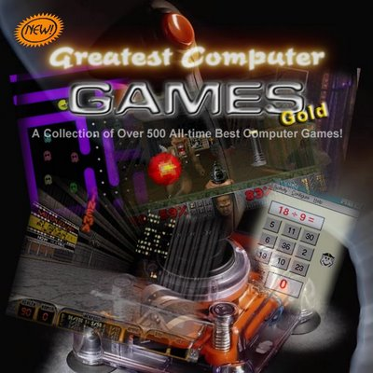

PLACE PHOTO

HERE,

OTHERWISE

DELETE BOX

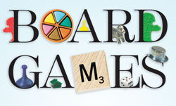

PLACE PHOTO HERE,

OTHERWISE DELETE BOX

Mrs. Bennett

Library Media Center

[kbennett@crestviewlocal.k12.oh.us](mailto:kbennett@crestviewlocal.k12.oh.us)

[**http://www.crestviewlocal.k12.oh.us/**](http://www.crestviewlocal.k12.oh.us/)

**(330) 482-4744**

Crestview local high school library

Come and get your game on in the library every last day of the 9 weeks!